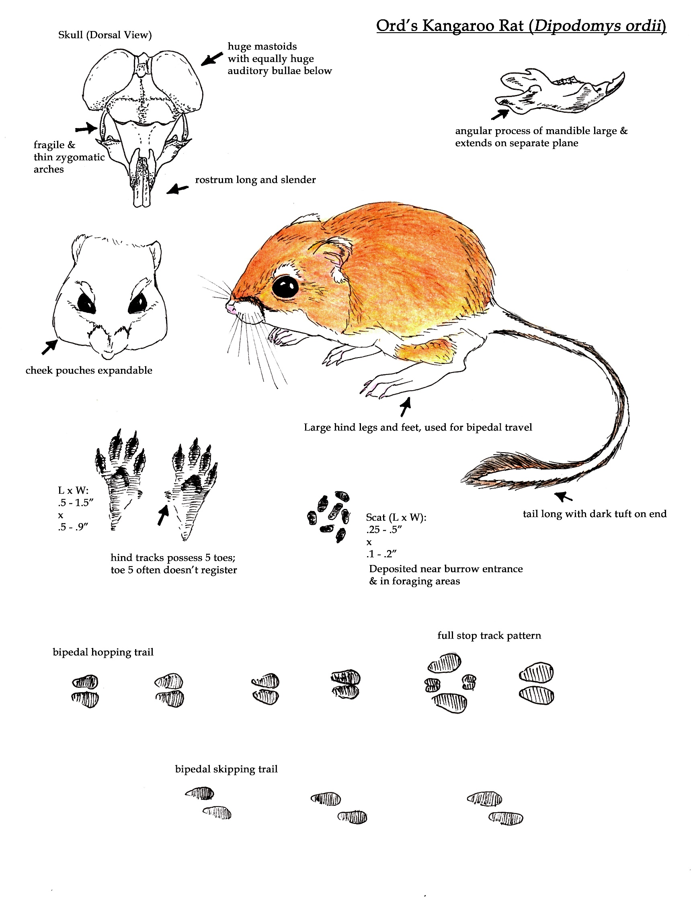
Habits: Strictly nocturnal. Activity reduced during bright, moonlit nights. Generally, forages before moonrise. Foraging lasts a few hours per night. In more vegetated areas, will clear trails heading out from burrow entrance. Typically travels by bipedal hop or rapid bipedal skip. Will bound at slow speeds, or stop and those are the only times the front tracks register. Tail drags register at slow speeds.
Diet: Mostly granivores (seed eaters), but half diet is also insects during the summer.
Seeds found by scent, and harvested either by cutting and extracting seeds or by sifting them from the sandy soil.
Sign: Caches: of seeds around their home range, though most the caches are located near the burrow entrances.
Burrows: round or taller than wide, 2.5-3.5” x 2.5 – 3.5”. Width of burrow entrance is influenced use and how loose the soil is.
Dust Baths: Shallow depressions typically longer than wide, 4-5” x 2.5 – 3.5”. Often show tail whip marks. These dust baths are made as a form of scent mark communication. These are spots that a tilled up, then rubbed first with cheeks then with the entire side of the body.
Predators: Large snakes, owls, foxes, coyotes, badgers and hawks. The massive auditory bullae allow them to hear low-frequency sounds including the wing beats of owls or the striking of a rattlesnake. They often hear these coming and escape with a high, vertical jump into the air. If discovered, snakes will be seen off by kicking sand at their face. Kangaroo rats will also drum their feet when they discover a snake, perhaps to alert the predator that it has been spotted.
Habitat: semi-arid grasslands, mixed grasslands and shrublands. Prefers spots with some loose, sandier soils.
